Project Design Phase
Solution Architecture

Date | 25 September 2026
Team ID | SWTID-2026-3946
Project Name | AI BlogNest
Maximum Marks | 4 Marks

Solution Architecture:
Solution architecture is a complex process – with many sub-processes – that bridges the gap between business problems and technology solutions. Its goals are to:
- Find the best tech solution to solve existing business problems.
- Describe the structure, characteristics, behavior, and other aspects of the software to project stakeholders.
- Define features, development phases, and solution requirements.
- Provide specifications according to which the solution is defined, managed, and delivered.

Example - Solution Architecture Diagram:

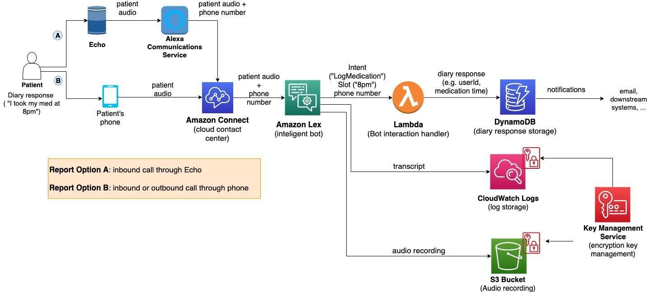
Figure 1: Architecture and data flow of the voice patient diary sample application
Reference: https://aws.amazon.com/blogs/industries/voice-applications-in-clinical-research-powered-by-ai-on-aws-part-1-architecture-and-design-considerations/

AI BlogNest – Solution Architecture
Client / Postman → Express.js REST API → Routes → Middleware → Controllers → PostgreSQL
↘ Gemini Service → Google Gemini API
PostgreSQL stores Users and Blogs. Relationship: users.id → blogs.author (one user can create many blogs).
Component | Responsibility
Client / Postman | Sends HTTP requests and displays JSON responses.
Express.js | Runs REST API and routes requests.
Authentication Middleware | Verifies JWT and identifies current user.
Controllers | Implement authentication, blog and AI operations.
PostgreSQL | Stores users and blogs.
pg Pool | Connects Node.js to PostgreSQL.
Gemini Service | Sends prompts and returns generated text.
Validation | Checks request data.
Error Middleware | Provides centralized error responses.
Project Structure: src/config/db.js; src/controllers/aiController.js, authController.js, blogController.js; src/middleware/authMiddleware.js, errorMiddleware.js; src/routes/aiRoutes.js, authRoutes.js, blogRoutes.js; src/services/geminiService.js; src/app.js; src/server.js.

